***Demonstration 1***

***Physical Techniques; Purification of Water***

***OBJECTIVES***

The objectives of this experiment are to observe physical techniques used to purify water: (a) distillation and (b) ion exchange chromatography.

***INTRODUCTION***

Mixtures are formed when two or more substances are physically mixed. The two types of mixtures are: homogeneous (a **mixture** which has uniform composition and properties throughout) and heterogeneous (a **mixture** that does not have uniform composition and properties throughout). Physical techniques are used to separate the components of the mixture. Examples of these techniques are: **Filtration, Distillation, Evaporation, Ion Exchange, Chromatography, Sublimation,** and more**.** Each technique is suitable for one or more kinds of mixtures depending on the physical properties of the mixture, such as its state of matter, volatility, and the miscibility of mixture components in each other.

The following are examples of how some of the above techniques can be used to separate mixtures.

* Filtration can be used to separate a solid from a liquid (sand and water).
* Distillation and ion exchange can be used to purify salty water.
* Chromatography can be used to separate the dyes in ink.

Two of the most important methods of removing salts to improve water quality are **distillation and ion exchange chromatography**. Although there is an abundance of water in nearly all regions of the world, most of it is unsuitable for human consumption or laboratory work due to impurities like dissolved salts. For example, sea water contains a large amount of with sodium chloride. Fresh water, which is suitable for domestic uses, contains some dissolved salts so that it cannot be used for laboratory purposes. Hardness of water is a common problem in many areas around the world. The existence of dissolved compounds of magnesium and calcium prevent soap from lathering and causes the buildup of hardness scale in water pipes, boilers and industrial equipment.

Distillation takes advantage of the fact (property) that salts are essentially nonvolatile (do not evaporate upon heating) and ion exchange uses the fact that salts are made up of ions. In this experiment, the instructor will demonstrate the use of distillation and ion exchange chromatography to purify a sample of water from a dissolved salt. Potassium permanganate (KMnO4) will be used as a salt to prepare the sample of water. The instructor will also explain the use of filter paper in filtration.

EXPERIMENTAL PROCEDURE

1. ***Filtration:***

You will be provided with a filter paper. The instructor will demonstrate how to fold the filter paper and make it fit in a funnel. Pour some muddy water in the filter paper and observe the filtration process.

*Question 1: Why does the water go through the filter paper but not the mud?*

*Question 2: What observation (Prediction) would indicate the water collected in the flask is pure?*

1. ***Distillation:***

The distillation apparatus shown in Figure 1 is assembled on the demonstration bench. Some tap water is placed in the distillation flask to which a small amount (few crystals) of potassium permanganate is added.

*Question 1: What color is the water in the flask?*

*Question 2: Is the water in the flask pure?*

*Question 3: What observation would indicate the water is pure?*

The electrical heater is turned on and cold water is circulated through the condenser. After several minutes, when the water starts dripping in the receiver, observe the color of the water in the receiver.

*Question 4: What is the evidence that the water in the receiver is pure?*

*Question 5: What is the reading of the thermometer? _______________.* This temperature is a fair estimate of the boiling point of water at your area.

*Question 6: A mixture contains three components; sea sand, table salt, and water. Describe how you would recover pure table salt from the mixture.*

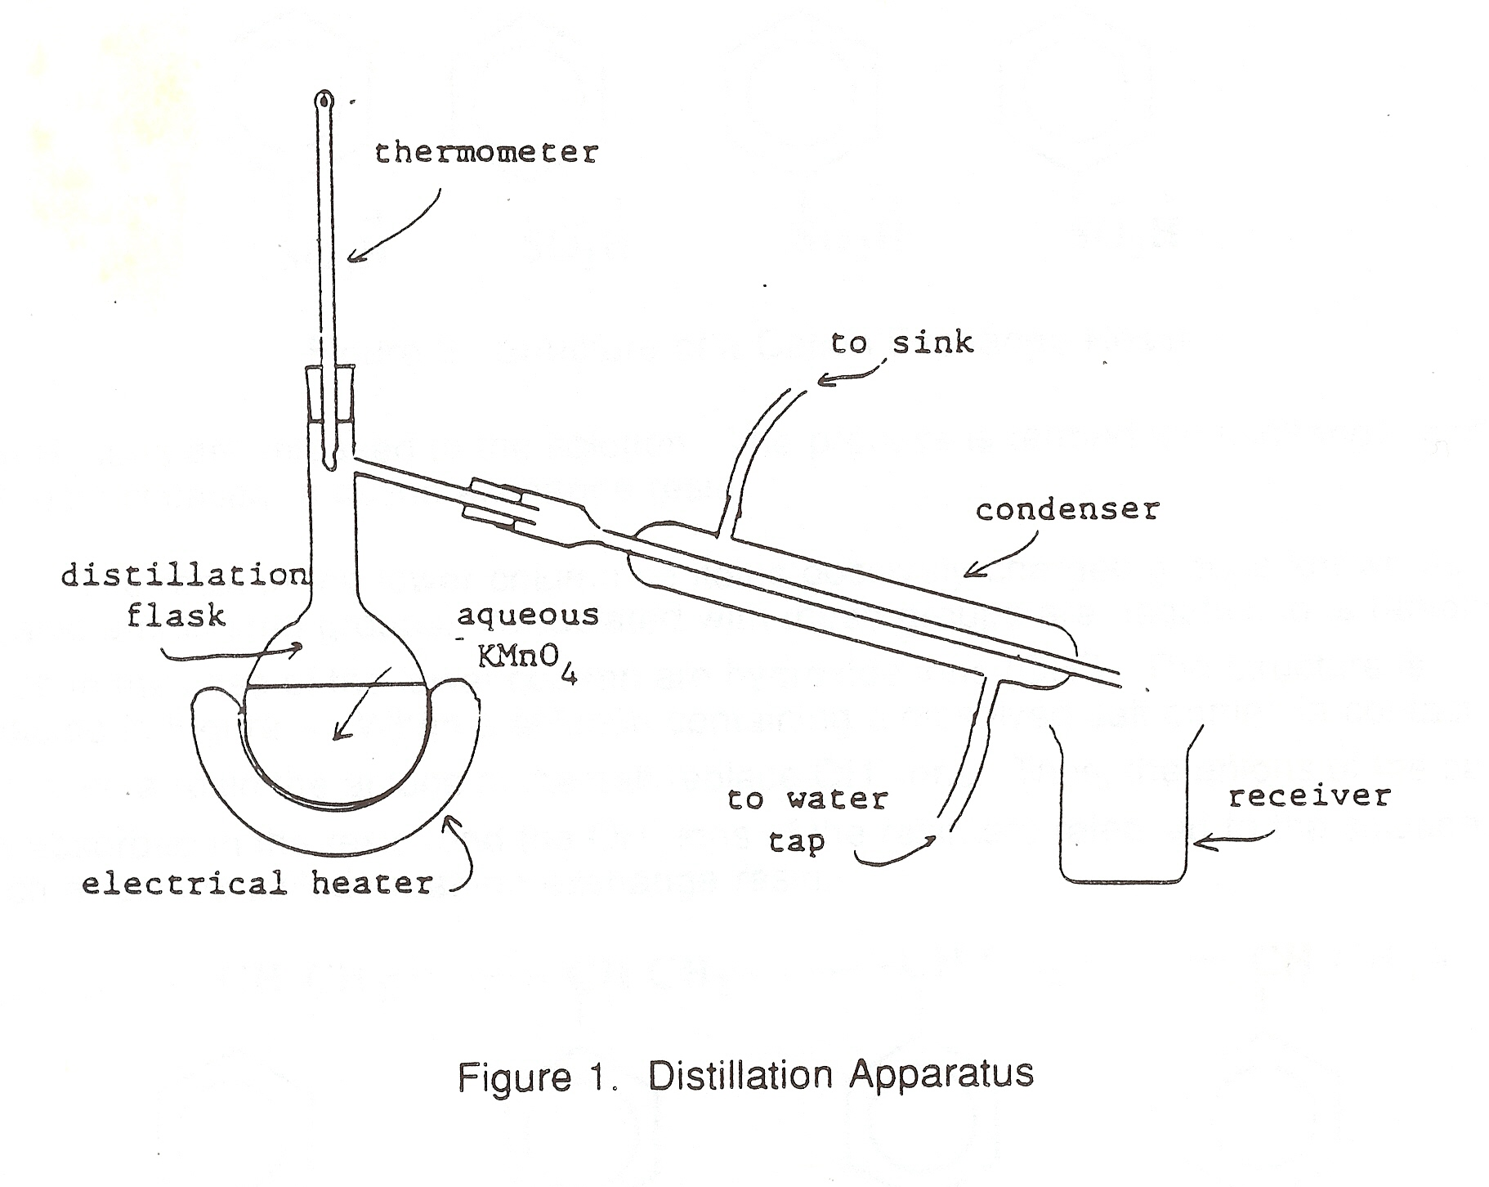

1. ***Ion Exchange Technique:***

An ion exchange column setup is used in this demonstration. The column is packed with small beads of a polymeric material known as an **ion exchange resin**. These beads are insoluble in water, but are porous, so that water can move through them. Since salts contain positive ions (**cations**) and negative ions **(anions**), both types of ion exchange resins, **cation exchange resin** and **anion exchange resin**, should ideally be used in this demonstration. The chemical structures of the resins are illustrated in Figures 2 and 3. The polymeric chains of the cation exchange resin contain sulfonic acid functional groups, which readily ionize to give hydrogen ions (H+), while the polymeric chains of an anion exchange resin contain ammonium functional groups associated, in this case, with hydroxide ions (OH-). When an aqueous solution containing a dissolved salt is passed successively through the two types of resins, the positive ions of the salt readily replace the hydrogen ions and are absorbed by (or attached to) the cation exchange resin, and the negative ions of the salt replace the hydroxide ions and are absorbed by the anion exchange resin. Thus the water comes out of the column pure. The displaced H+ and OH- ions become a H2O molecule.

In this demonstration, about 10mL of aqueous potassium permanganate solution will be used as an example of a mixture. The solution will be added to the top of the column and allowed to pass through the resin. The column will then be flushed several times with distilled water. Drops of will be collected at the bottom of the column.

*Question 1: Is the water collected at the bottom of the column pure? Explain.*

*Question 2: Compare the two techniques (distillation and ion exchange) and list some advantages and disadvantage for each technique.*



Figure 2. Structure of a cation exchange resin



Figure 3. Structure of an anion exchange resin

*Question 3: Define sublimation.*

*Question 4: What physical technique, if any, can separate the hydrogen and oxygen in a sample of water?*

*Question 5: What is hard water?*